Custom Project
Name: Joshua Eng Han Ruong
Student ID: 36340197
Date: 30 April 2026

Learning Journal

<This is pretty much freeform. You have a lot of experience now with the format of our Learning Journey in the previous tasks, but this is your journal.
At the end of your custom project, we will want to hear from you about everything you did along the way. Your initial design - even though it changed. Your changes - and your thoughts on why it changed and maybe how next time you might start out differently to avoid that change. We expect changes! The whole point here is that when you start this project, you don’t know much about programming and especially designing larger programs. So, we don’t want to see “yeah I just did this”. What tells us you have learned is your record of “At the start I did it like this. But now I know that isn’t very good and here is what I would do differently”. That *is* your learning! So, start by recording all the things you do for this project. Then as you go, don’t delete anything “because it was wrong”. Celebrate it and show us what you would do now that is better! Keep the mistakes, that’s the learning journey!
We recommend entries here at least weekly - preferably more often. Every time you work on your custom project, you should log here what you did - because every time you work on it you should be pushing yourself beyond the Distinction tasks, so it should be learning. Screenshots, diagrams, code snippets, error messages, frustrations, log it all! Every week, maybe submit this and a quick recap in the “submission template” and ask your TA for feedback - you will need to be specific there, don’t assume your TA will read everything every week. But ask “Hey, I hit this snag and I solved it this way - can you look at page 4 in my journal and tell me what you think? Then you will have great evidence of continual progress.>

5 May
Made all the separate header and implementation files to hold all the classes. I find it neater than having it in one long file and separating the classes by kind also makes it easier to find where classes are located. Since each file needed to include several other files, I predicted it would cause errors as the files would be included several times. To avoid that, I preventatively placed #pragma once at the top of every file (I remember what it means from past readings around the Internet) and did a test compilation. The first issue was that it should not have been in the implementation files, only the headers, so I fixed that. The second issue was that files that cyclically imported each other would produce errors because of the nature of pragma once. After some searching online, I added forward declarations wherever needed, but it still took a LOT of trial and error to get everything ironed out. Then there were problems with redeclaration since I declared classes in both header and implementation files. I was confused since this wasn’t a problem before, but before I must’ve done something differently. I just removed the redeclarations. Without those I was confused how to add implementation to class functions, but it turned out in C++ it is possible to define class functions outside the class itself by specifying the class name. I also set up the main concept to use in the menu system.

18 May
Last Friday my marker told me I should include graphics, otherwise the project may not be impressive enough to count for HD. I am apprehensive at this, since not only does it invalidate almost all of my previously planned structure, I know from experience that low-level graphics is extremely frustrating. Hopefully Splashkit makes it easier. Deleted most of the files to make room for the new structure. I don’t know what it will be; I’ll make it up along the way and in a project of this small size code debt won’t have a chance to catch up.

Over the weekend I fleshed out the idea more. On the technical side, the screen will be split into two, with the top two thirds for action (action screen) and the bottom third for inventory and stats (info screen). If the game requires you to make an option, the options will temporarily replace the info screen. The game is a linear series of a set amount of randomly generated rooms. Once the player clears one, they immediately move to the next and deal with whatever encounter is in there. Usually these will be battles, but on set intervals there are merchants, chests, puzzles, and extra things like piles of gold or something. The goal is to defeat the boss at the end. The player has one melee slot, one spell slot, and 12 inventory slots. If there’s time, I’ll add accessories. They start with a basic melee and spell, and can get better ones through monster drops, chests, merchants, etc. The player also has three bars: health, mana, and boil. Health and mana should be familiar. Spells cost mana to cast, while melees (usually) don’t. Both regenerate over time but can be manually replenished with items.

Boil is an interesting one and is tightly entwined with the narrative side of the game. I planned to go for a deliberately simplistic art style since my art skills are pitiful. Think Kingdom of Loathing. However, I also didn’t want players staring at still images the whole time, as that would be boring. Thus, I plan to use a technique called line boil whereby still lines wobble slightly in place. I had a random thought that line boil sounded like some sort of plague for stickmen and other line creatures. Out of that came the idea that the player is entering a dungeon to find and defeat the source of the line boil, a disease that is ravaging their country. It drives the infected mad and makes their lines boil, with worse infections leading to more boil.

However, the player themselves is not immune to it, which is where the boil meter comes in. Boil passively accumulates as the player goes through rooms, even non-battle rooms, and also increases under certain conditions, such as getting hit by a boil-infected enemy. Defeating enemies is the main method of decreasing boil, but certain consumables and random encounters can also do it. The more boil the player has, the more the UI’s lines boil, and when it reaches full, the player immediately dies.

So now there are two resources to manage, boil and health. It may seem that they are essentially the same since enemy hits both decrease health and increase boil, but there is also the option to flee a battle. Doing so keeps the player’s health up, but deprives them of a chance to decrease their boil, since after they immediately progress to the next room. Some enemies also deal more health instead of boil, or vice versa. Thus, the player must choose their battles carefully.

Is this what I’m supposed to put in this document? Eh, even if it isn’t I’m keeping it in. I’m really quite proud of this idea.

19 May
Started work on the project itself. Just wrote some boilerplate first and thought about how much to put into the game’s core loop function. Opening the window? Loading resource bundles? Processing events, clearing the screen, checking for quits, et cetera. All of this could go in the main function, or the game function. Unless the game needs to intercept anything I’ll be conservative in what I put in the game function for now. Separation of concerns and all.

Decided to make the game a singleton as the game object that will handle everything. Also found out you cannot initialise a class instance as a static class member, so I’ll just create a game in the main function and trust I won’t do it anywhere else. Maybe I should put a flag as a static member just in case. The internet said to define it in a header file or use a static function variable and call the function to get the instance, but both of those seem rather tedious.

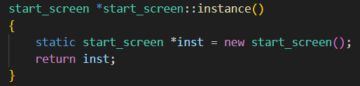
I did use the static function variable method to make the screens singletons though. The idea is the screens are all singletons whose pointers are swapped in and out of the game object, so the game doesn’t have to know anything about individual screens and can just call their update and render functions. Pointers have to be used since all screens inherit from a base screen class and polymorphism only works through pointers.

Ran into some problems with pragma once again and solved them the same way as last time. Also got some linker errors but discovered that was because I wasn’t including new files in the build command.

Started work on the start menu, which involves buttons. Couldn’t use the default button because I wanted custom art, so I’ll code my own buttons. I considered creating a struct or class for the buttons but I’m quite sure this is the only place in the game they’ll show up so it seems overkill. It’ll be okay to store all the button info directly in the start menu instance, and if I need more buttons in the future I can always refactor.

As soon as I started the menu the console was flooded with warnings saying the program was attempting to draw to a nonexistent surface. This was strange, since I was using the normal procedures. The window definitely existed, and I assumed loading a bundle would also load everything inside it (I was putting all the resources in a single bundle). I tested each call by commenting out the others and found it was draw_bitmap that was causing the issue. The first thing I did was go back to the example in the docs. I confirmed I’d done everything correctly. The only difference was that the docs loaded the bitmap object by name first and I directly used the name. It didn’t seem like it would make a difference, but I tried anyways and it didn’t work. The next thing I tried was simplifying the call. Removing the drawing_options worked, and from the docs I figured out that was because the options stores a pointer to the active window, but it was created before the window and never updated. I moved the creation to be after the window and it worked.

Was wondering if //region and //endregion would create collapsible regions like #region and #endregion in Python. Found out through autocomplete and accidentally typing # instead of // that the alternative in C++ is #pragma region and #pragma endregion.

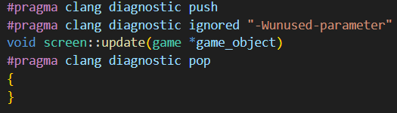
Found it annoying to have unused parameter warnings pop up every compilation since the unused parameters are needed to preserve the type signature of the virtual functions they are used in. Searched it up and found a bunch of pragma directives to do the job. A bit verbose, but it works.

20 May
Decided to use caching for mouse properties for each frame. Instead of calling the Splashkit functions for every check, they are called once at the start of the frame and the results stored in the game object. This not only saves on time but also enables mouse clicks to be detected by moving the current value into another variable before updating it. Splashkit defines a click as the button being up while it previously was down, but I find the opposite definition is more useful for my current needs. Honestly Splashkit probably caches as well whenever process_events is called.

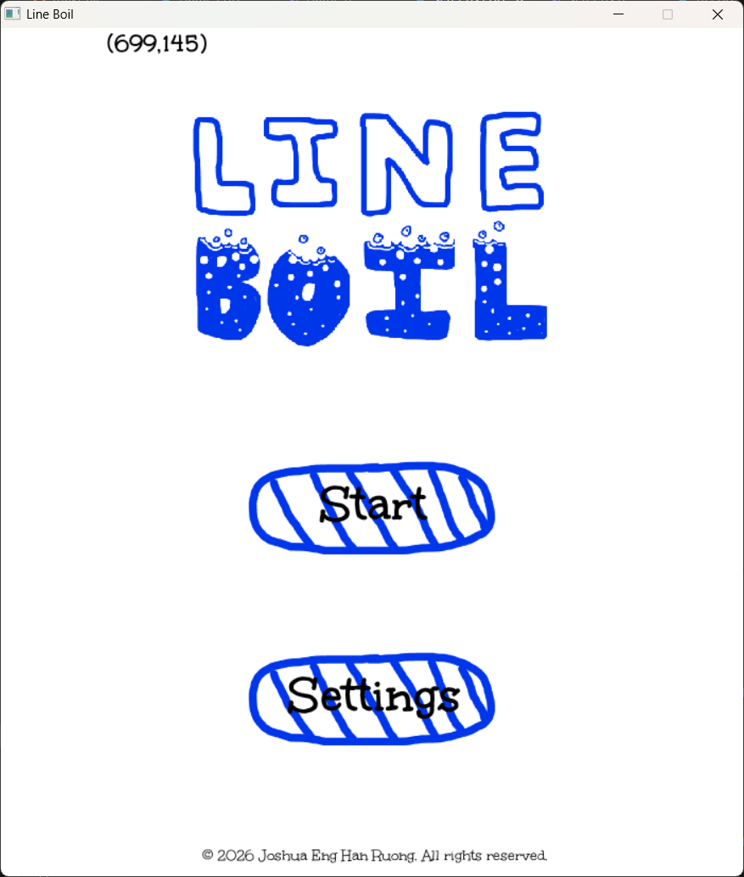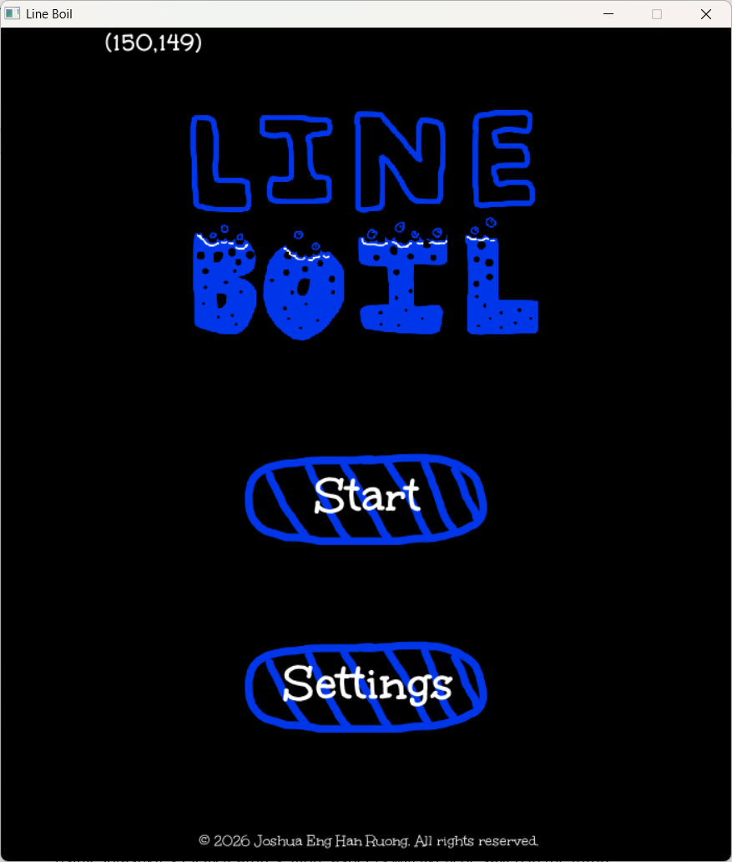
I also implemented a colour palette switching system (just dark and light for now) and combined all the colour information into a class to make palette switching easier. I considered using a struct but decided against it to have multiple constructors. A strange error cropped up in the game constructor saying the palette class had no default constructor, which was odd since I never used the default. It turned out that C++ calls the default constructor on all members of a class to initialise them before assignment, so I just used an explicit default constructor to appease that. Since the palette is immediately assigned the default never shows up. I read a bit about member initialiser lists but I think the default keyword method is simpler here. Also each palette is a function returning static variable since this language doesn’t allow initialising static class members inside classes. Also made a save system and file for the colour palette using Splashkit’s JSON features. More aspects will likely be saved in the future.

21 May
Starting work on the main body of the game. First thing I realised was that even though I originally split the screen into upper and lower segments, the drawn border didn’t really fit with either since it shouldn’t change with either. I could’ve just made it a part of the upper or lower screens and made sure all of them rendered it, but it didn’t seem neat. Thus, I created another category of screen for the game object to render, called the overlay.

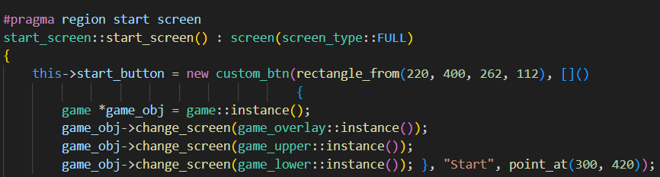
Decided to refactor the buttons into their own file since they’ll be used again in the pause menu. To allow them to act I made them accept a function pointer, which will usually be a lambda. However, I ran into an unforeseen issue. Button effects usually affected the game and therefore needed access to the game object, which was inside the main function. The object was not passed to screen constructors, where the buttons were constructed. It also could not be passed in since the screen objects were static function variables, and adding the game object as a parameter would require it to be called with it every time. So, I made the game object into a static function variable as well, so it can be accessed any time. I think there is probably a better solution, though, since exposing the object globally like this could be messy.

Include order problems cropped up once more, this time around the button class. I already knew how to solve this and put in a forward declaration but then ran into the issue that the button class was incomplete in that file and couldn’t be used as a member type. I looked it up and found I had to either change the include order, which I wasn’t willing to do since it could cause other order problems, or use pointers. Pointers it is. Had a bit of a scare since suddenly the buttons weren’t working. Turned out to be the I forgot the static storage specifier. Worked after that.

Added documentation to everything as per marker instructions. It’s a bit of a hassle since a lot of my methods do the same thing and take the same parameters, just for different components, but I understand the necessity of thoroughness. I don’t think the more minimal constructors have to be documented though. It’s quite obvious what they do, and the parameter names are self-descriptive.

23 May
Got the pause menu done pretty easily. One of the benefits of having UI elements be separate objects. Added a few convenience functions and made the UI for the lower part of the gameplay screen. Since that’s started also filled out some basic properties of the player and entities

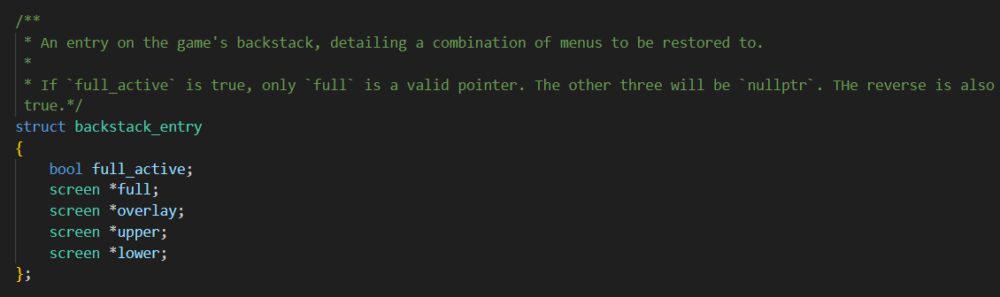
I didn’t think I would need a backstack since I couldn’t think of any menus that would be reused, but I didn’t realise that upper and lower menus can change over the course of the game, while the pause button leads out from all of those. So, I created a new struct to house information on a set of menus and a dynamic list of those structs to enable backtracking. The menu itself doesn’t have to know what came before it and can just call a function on the game instance. I’ve implemented this sort of structure in the past so I’m confident in its reliability as long as I made sure to properly add and remove entries from the stack. Since the game can have a full screen menu or a few separate ones, the struct has a flag indicating which type of menu it is storing, while irrelevant fields are set to nullptr. Again, as long as I’m careful when handling entries no errors should occur.

I refactored the data saving function out of game’s destructor since the same code was used by the save and quit button of the pause screen. However, after I did that the game would no longer save on closing, only with that button. I inlined the code back in and it still didn’t work, which is confusing since the exact same code worked before. In fact, it seems the game’s destructor wasn’t even being called. I think it was the change into making the game object a static function variable, since that meant turning it into a pointer. Thus, it is not allocated on the stack of main and its destructor must be manually called. I added that manual call and it worked, but I’m still baffled. According to Google static objects like this are still destructed, so I really don’t know. I also learnt destructors should be declared virtual to be subclassed properly and I wasn’t doing that for the screens. Oops.

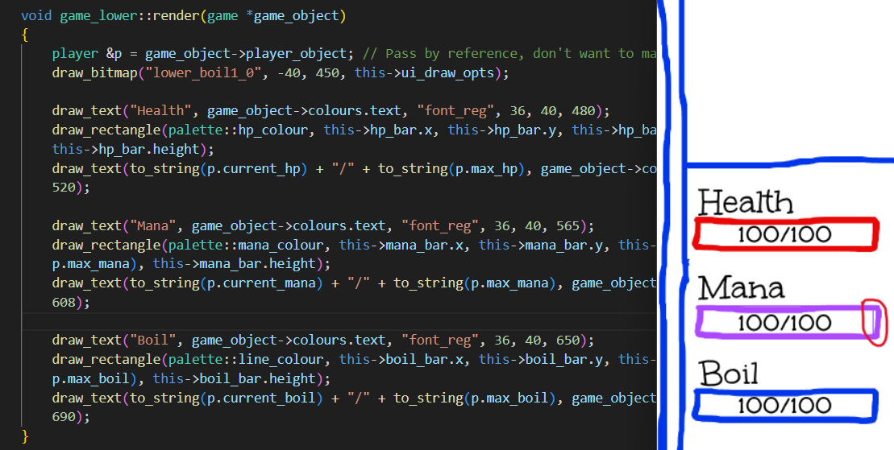
Went to draw the various status bars and they weren’t showing up. Thankfully I noticed a thin line where the rectangle boundary didn’t exactly meet the status bar boundary and that spurred me to remember that draw and fill rectangle are different things. It really bugs me that the numbers aren’t actually centred, but rather anchored to their top left corner. There doesn't seem to be any way to measure text, though, so I’ll have to live with it for now.

I just had a thought. Why bother with static function variables for singletons when I could just make everything static? There’s only one instance anyways. Hmm. Oh yeah, its because of inheritance. Types aren’t objects in C++, so to allow accessing methods and members through a pointer to some derived class it has to be an actual object and not just the class. Phew, good thing there’s a justification, even if it is after the fact. I would hate to have to go around changing everything.

Speaking of coincidences, the reason I chose that odd shade of blue as the main line colour was pure vibes. I thought it’d go well with white. Later I wanted to add a dark mode and was very thankful I didn’t go for the more conventional black, since I didn’t want to have different coloured versions of each asset or redraw the assets to be a more high-contrast colour. I do not enjoy drawing.

Started working on items, since those have to be done before entities. Got the idea of splitting item types and stacks into separate classes from Minecraft (I had a brief foray into modding). Quite an ingenious idea, really. Each item has a single instance that controls its behaviour, avoiding having to create separate instances for each stack. Because of pointers, I also don’t have to deal with generics like in Java.

24 May
Been thinking of how to implement items. They interact with the game in such wide and varied ways, it really is a bit of a puzzle. I had to bring in std::map since items have different attributes, i.e. ways they can affect things, but the game doesn’t know what they are except from the item_type member. This does not satisfy the type checker, and I didn’t want to make each attribute its own member since non-pointer types are non-nullable and it would also be a great pain.

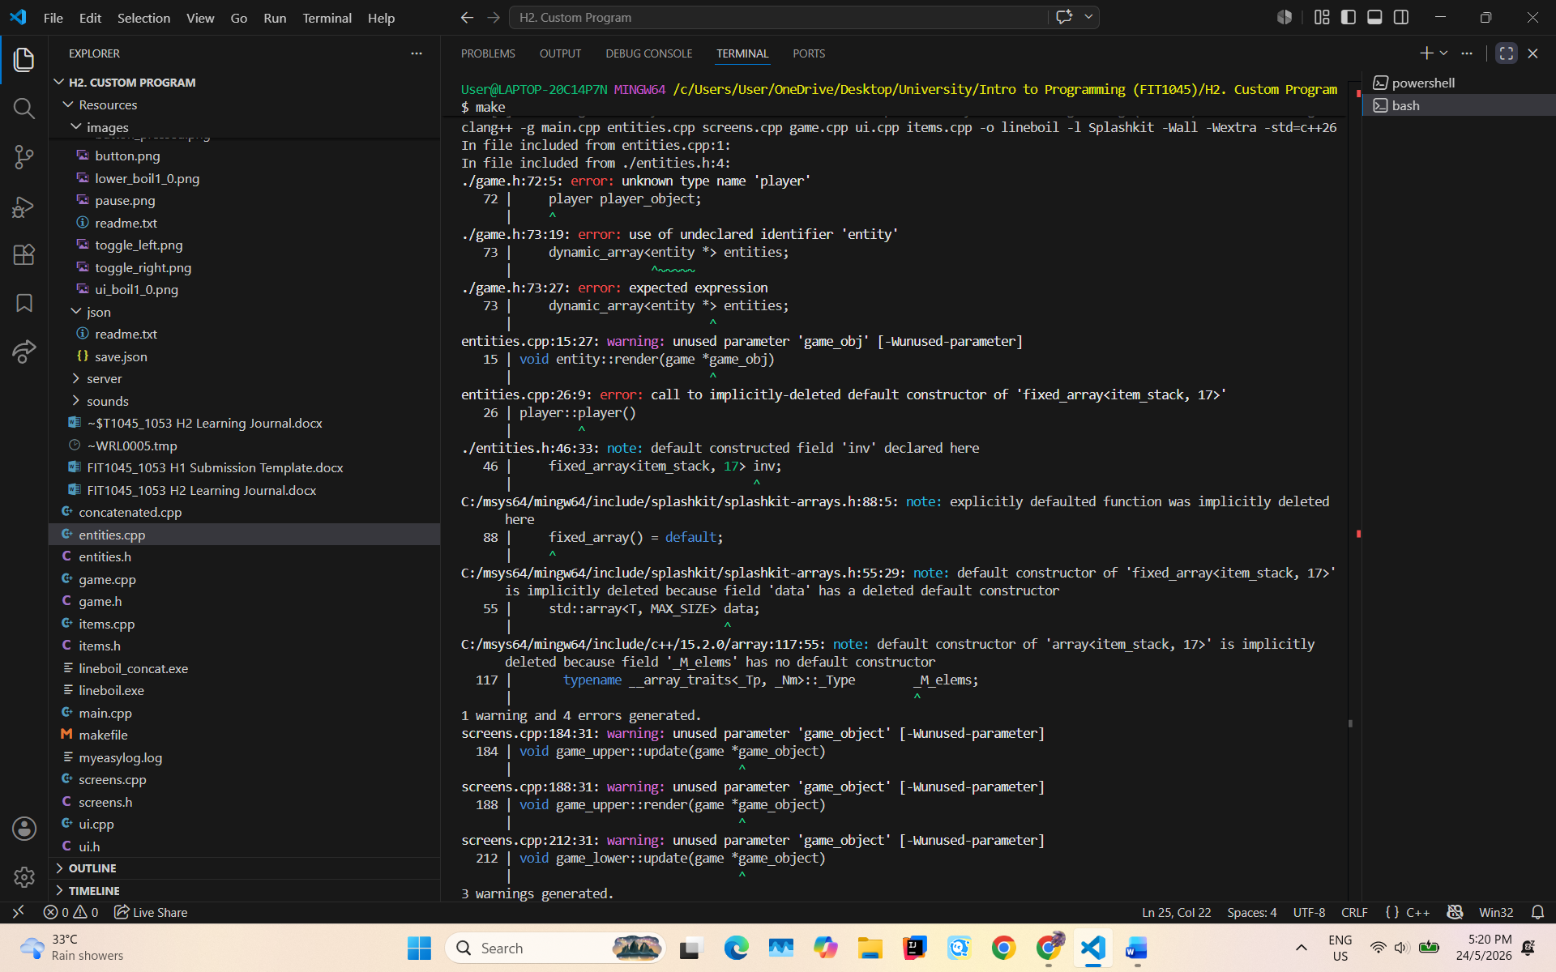
So many undeclared identifier errors every time I add a new file, nothing to do but put forward declarations, then that leads to incomplete type errors, so everything has to be a pointer too. Somehow that also gets rid of another error I had where it said the default constructor of dynamic_array was implicitly deleted, even though the header clearly says it exists.

Wanted to make base item functions pure virtual but I actually do need instances of the base item for testing and placeholding, so I guess they’ll have to be less elegant blank implementations instead.

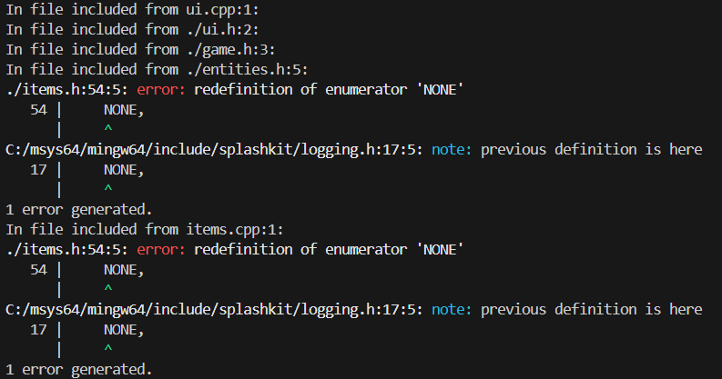
Here’s something a bit odd. I have an enum with a member called NONE, a placeholder because null isn’t allowed. That doesn’t make sense, surely. Each enum has its own name by which its members are distinguished. So I searched it up and found that regular old enums actually enter the global namespace, while enum classes get their own, and I hadn’t realised since I always prefix enums with their namespace. I think I got the habit from an error message earlier in the year and musn’t’ve (ooh, double apostrophe) realised that was for an enum class instead of a regular enum. I remember hearing somewhere to prefer regular enums, but it seems enum classes are better and provide several other features.

Ended up needing to move the lower screen rendering code into the player class, so it could deal with item interactions and whatnot too. I originally wanted to avoid this because the screens are supposed to do all rendering work, but its not feasible now, at least with this architecture. Maybe a smarter design would’ve avoided this. So I suppose entities and items will render themselves too. This is what happens when you try to be smart.

Added a registry system for items to enable them to be loaded from JSON from their id numbers. Every item automatically registers itself when constructed, and with the item/stack system each item corresponds to exactly one entry. A neat idea, but I realised static function variables are only instantiated the first time the function is called, meaning at the start of the program the registry is empty. Thus, every item must be manually registered first with some sort of function. It doesn’t seem particularly elegant, but I can’t think of anything else.

25 May
Spent the whole day getting items to render and interact properly. Not very exciting. In fact, there was a lot of downright tedious nudging and aligning. One of the things about working with graphics without a proper game engine is that positioning things can take a while, as every change leads to a recompile.

It also occurs to me I should’ve used references more instead of pointers. Less hassle and safer. Well, it would be too much work to change all of it now. Let it be a lesson for next time.

What if the player’s inventory was a linked list? A lot of operations involve moving down the inventory slots until a condition is fulfilled. But there are also some that need to target a specific slot. I wonder which is better in terms of performance. At least its probably negligible so I don’t have to worry, just wonder.

Pretty sure items work. If any glitches turn up later I’ll tend to them. Now for enemies. Oh wait, I forgot about tooltips. Eh, I’ll do them later

Turns out Splashkit actually can measure text. That’s useful to know going forward.

26 May
Made the player a subclass of entity. I originally thought they were too different to be placed in that structure but later I realised they share many of the same methods, just with different implementation, so making the base entity class mostly functions, like an interface, would work. This means that functions now don’t have to have separate implementations to deal with entities and players separately.

Had a small crisis about screen and memory safety. There are some screens, such as the attack lower screen, whose content must be regenerated every time an instance is required. This works fine with the existing structure since the game takes pointers from a function and doesn’t care where the pointer came from. However, since these “transient” menus are temporary, they must be deleted afterwards. Telling the game a menu is transient is simple, just add a flag. Telling it when to delete is much harder, since menus that are switched out still live on the backstack. I had a brief idea of using function pointers instead of menu pointers and delete transient menus immediately, but I realised the screen could still be a singleton, just calling the instance function also calls a private function that changes its content. All my fretting was for naught.

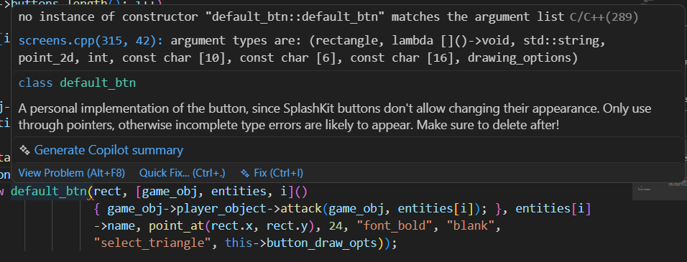

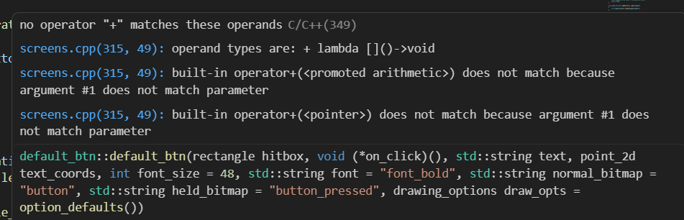
Here’s something of a problem. At first glance, this instantiation of a button perfectly matches the constructor definition, and yet the compiler throws an error. I suspected it was the lambda since implicitly converting lambdas to pointers was an issue in a past task, so I added the “+” operator (strange choice by the devs, by the way) to force the conversion and found that didn’t work. Comparing with my last use of the operator, the only difference was that this one had captures. Sure enough, removing them solved the problem, but the captures were essential. Was there really no way to just turn it into a pointer? StackOverflow tells me no but std::function can be used as an alternative, so that’s what I’ll be using. The best part is that lambdas can be implicitly converted to it, so I don’t have to touch any old code that uses buttons. As a side note, isn’t it ridiculous C++ doesn’t allow you to specify default arguments when calling? If you want to specify the last default, you also must specify every preceding one. C’mon guys, its 2026. Pretty much every language that has defaults allows it.

I keep wanting to use pure virtual functions but there’s never a proper scenario. Something always comes up that makes them need default implementations.

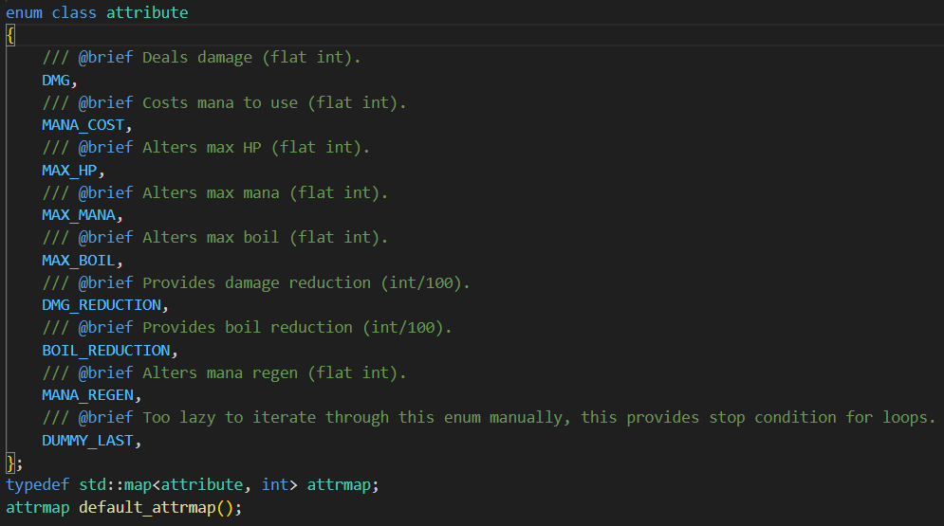

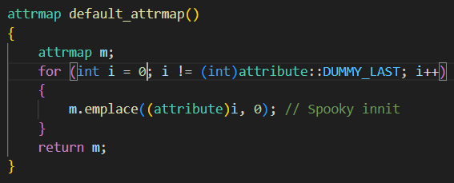
This is an interesting little thing. It feels kind of cursed to iterate through an enum like this, but its C++’s fault for not equipping them with a default iterator like Kotlin. I’m definitely not going to change all the assignments manually every time the attribute list changes. Imagine the bugs if I miss something. And hey, if it works it works. I suppose I could stuff them into a vector and iterate over that, but I would have to change the vector arguments then. It seems trivial, but if there’s an option that requires even less effort, why not take it?
Things are starting to work, right on time. Enemies, items, attack phase starting. The main mechanics should be done by the end of tomorrow.

27 May
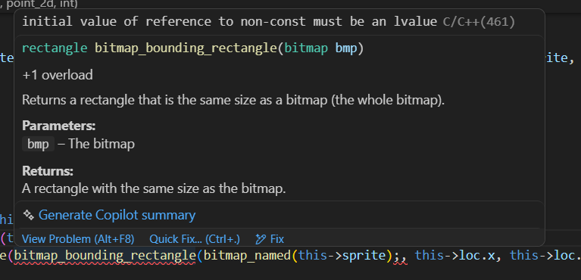
Was working on centring things and encountered the above error. I had no idea what an lvalue was, so I focussed on the first part. Clearly there is a reference somewhere, and it is not constant. Since the red squiggle was on the function name I assumed I was passing it incorrect arguments, but its signature didn’t involve any references. I Googled the error message and it said an lvalue was something modifiable, and I was trying to pass a non-modifiable object into a situation where it could be modified. At this point I realised the real problem was the function I was passing it into, which did take references. I changed the signature of that to const and the error was fixed.

I made another kind of UI element, a list of buttons, and at first I wanted to use fixed arrays and make the length a template parameter. That way the lengths of all the arrays were forced by the compiler to match, with the downside of having the implementation in the header file itself. I found it a bit discomforting since everything else had their implementations in the proper file, so in the end I decided to make it a regular parameter and do the checks manually.

I might’ve cornered myself somewhat with my architecture. Problem is, there are 3 classes of entities: players, enemies, and NPC’s. They are all quite similar, but just dissimilar enough that none of them can inherit from one another or a common base class without adding dummy functions or fields. They can’t be separate, either, since the game only keeps one list of entities to display, so enemies and NPC’s have to at least inherit from the same class, and many functions must take players or enemies, so same goes for those two. I think it could be solved by splitting the NPC’s from players and enemies and having those occupy a separate list. It’d be a huge hassle at this point though. I’ll do it if I’ve time after. For now, band-aid solutions like this work. (Ended up doing it anyways).

Added a ticker system for animations. I know Splashkit already has animations, but those are spritesheet-based. I’m looking for simple blinking or moving images. Tickers are essentially just functions that are called every frame until they expire (return false). They are controlled using static timers, but the problem is timers must be freed. Tickers also cannot persist after a screen has been swapped out (it wouldn’t make sense), so they have to be cleared whenever a screen is swapped. However, screens can also be nullptr, so then some convoluted null checks must be done. It would be simpler if the screens were somehow forced to never be nullptr. Another reason I should’ve used references instead of pointers. I’ll leave it for if I have time. If it segfaults while switching menus I know where to look.

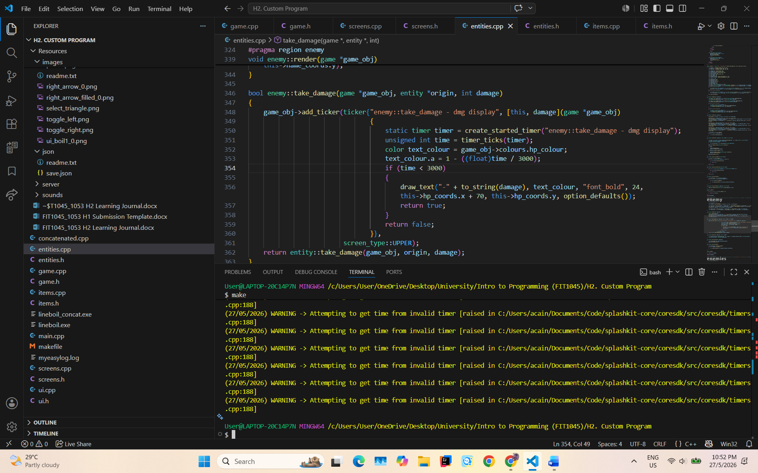
Another interesting problem. Static variables are constant over all instances of the lambda. Just have to move it into the enclosing scope and capture it.

28 May
Had the final meeting with the marker for the semester. He didn’t have much to say except adding a navigable map instead of having the rooms be linear. I think it’s a decent idea, but it introduces balancing issues. I’ll add it if I’ve time.

Refactored and added some stuff, forgot to write in this for the morning so can’t remember many details but I added death, is the main thing. Now that the infrastructure is in place items, enemies, and the like shouldn’t be difficult to add.

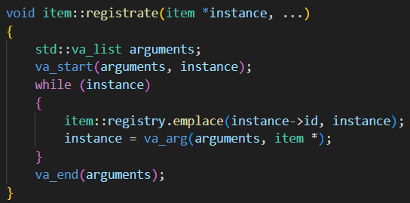
I mentioned earlier that items needed to be registered when the program starts, but the registration function only took a single item. Thus, it needed to be called separately for every item. To make it more compact I searched up whether C++ had variadic function arguments, and it did. However, I couldn’t figure out how to actually access the arguments. It is not at all clear from the reference what va_list, start, arg, and end are or how to use them, so I needed to search up an example as reference. The code works, but I still have no idea what’s going on behind the scenes. How does va_start access the arguments when the function itself can’t? What is really inside va_list and how is it used? Why can’t this language just go like Python or Java and encapsulate the arguments into an object.

Still a few annoying things to contend with. First is that some simple items can be global variables, since they have one pointer each. In the regular fashion I tried to declare them in the header and define them in the implementation, but apparently that’s not allowed. Either do both in the header or the compiler will throw an error in the implementation. The solution, I found on the Internet, is to use the extern keyword.

The second is that in order to randomly generate enemies the game needs to know what enemies there are and their spawn requirements. I first thought of a registry like for items, but enemies can have multiple instances, so they cannot be represented by a single pointer. In that case, they could be represented by a pointer to their constructor, so long as the constructors all take the same arguments. Except referencing constructors isn’t allowed. Again I turned to Google and came across the solution of encapsulating the constructor in a lambda, which does seem to work, so that will be used instead.

Definitely the most cursed thing I wrote the whole week. Probably month. Doesn’t really work, either. Man, I spent a good 40 minutes trying. The idea is to drastically reduce boilerplate by automatically converting type names into constructor lambdas for registration. It just doesn’t work, and for the strangest reasons. I’d better cut my losses and go the manual route.
I really can’t give up on my ideas.

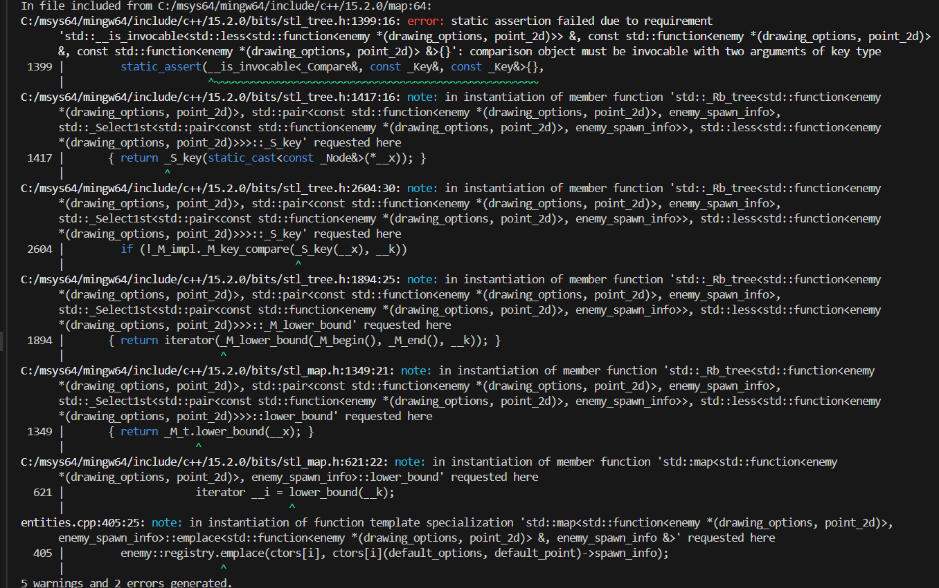
Well. No red squiggles appeared, but here’s what happened when I tried to compile. WHAT DOES THIS EVEN MEAN??? Its almost midnight, I’ll leave it to tomorrow.

29 May
I woke up today and thought of the solution. Clearly map keys have to be comparable, which functions are not. I’ve encountered this sort of problem before, and usually I’d just make it into a list of pairs instead of a map. I don’t think I’ll be needing random access here, so I don’t see why not. I’ll also be using std::vector instead of Splashkit’s dynamic_array since it can be brace-initialised, so I can create it in place instead of outside then passing it into the function. And it can be iterated over with C++’s native iteration syntax.

Finally, it works. It just keeps getting more and more cursed. Now I can effectively encapsulate the info to spawn enemies, I just need to figure out the spawning algorithm. I know it’ll be value-based, as in every enemy has a value and the combination of enemies in a room sums to the room’s value, but how to partition value across enemies and use that information to decide which ones to spawn is quite complicated. None of the solutions I thought of are satisfactorily balanced.

Found out the difference between const and constexpr.

I’ve always like monads. They have a certain elegance in their construction and preparation. I got a chance to implement one in the form of tooltips, over which I also spent ages agonising the correct structure for. Should the render on the fly, or keep a cached bitmap? Should they detect changes immediately, or should a function be called? Should they be stored as temporary objects, or be single instances regenerated every time? Objects, pointers, or references? So many things to consider, each with pros and cons.

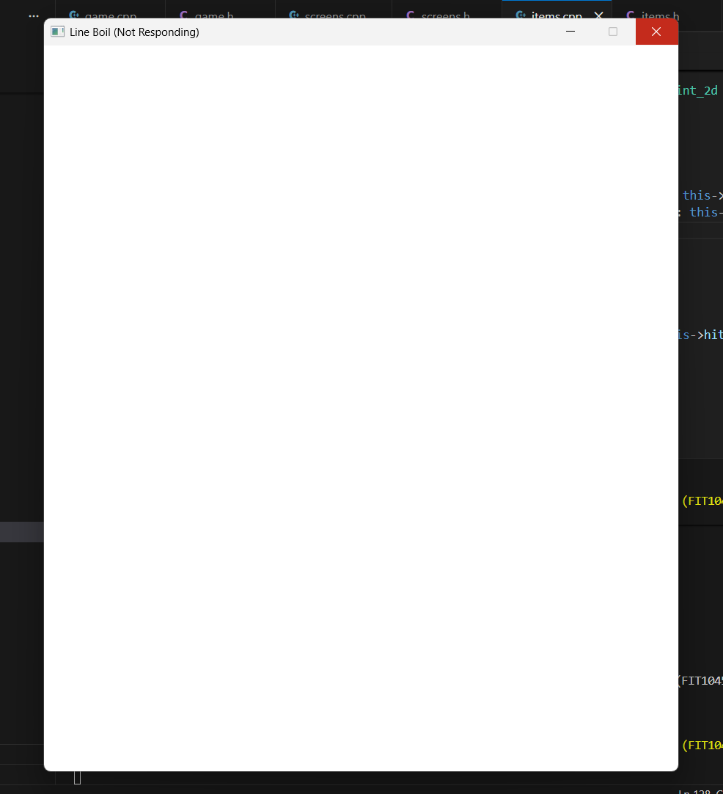
Uh what?
The only thing I added was tooltips. A process of complete commenting-out and successive uncommenting should do it.
The second allocation of item_stack always triggers it.
But if ectorpair is active it’s the first allocation.
Therefore it must be the first allocation inside player that triggers it. Tested and confirmed. This occurs regardless of the constructor used (this makes sense, as they all delegate to the most verbose one).
The cause has been arrived at. While instantiating game, a player is instantiated. The player instantiates an item_stack, which instantiates a tooltip. Then, the item_stack adds a string to the tooltip, and for the colour of the string, refers back to game for the current palette. Presumably the program stalls because game is still an incomplete object. Perhaps it has not been properly allocated yet.
Even after setting the colour, the tooltip cannot be generated since that also accesses game for the colour.
It still doesn’t work. Now the player has nothing to do with it.
Ah, the ground gets populated with item stacks too.
Yep, it works. Note to self: Never instantiate item_stacks in game’s constructor. Do it in reset (which I called after instantiation since it conveniently creates all the item_stack-related things).

Left a break in when converting a switch statement to a loop. There goes another hour.

30 May
Finally got tooltips to work. Incredibly satisfying. Making them is trivial now that the infrastructure is there.

Decided to start working on the map, which would involve some sort of generation algorithm to set the map at the start of the game. My proposal goes as follows:
- Generate a single starting room.
- For each room in the current layer, there is a repeated 50% chance it branches. Track the amount of open ends.
- If there are still open ends, generate a room and add it to the next layer. Otherwise, proceed with the next layer.
- The room is attached to the first open end.
- There is a repeated 50% chance it attaches to the next open end.
- If attachment fails or there are no more open ends, set positions and go to step 3.
- Do this for as many layers as desired.
I tried to make a flow chart to better illustrate the process but I’ve no idea how to chart a for-each loop.

The algorithm is frying me. Its surprisingly difficult to translate the flow of logic into code, and there’s also lifetimes to contend with. If I copy rooms everywhere, I risk some changes being unsaved. If I reference them, I risk the rooms themselves being destroyed with their scope and invalidating the references. If I use pointers, I risk memory leaks. On the whole I think pointers are the best bet. They are guaranteed to not be invalidated unless explicitly destroyed. The app might use a bit more memory than it needs to but its better than crashing or undefined behaviour.

The map has an odd parallax effect, which makes no sense since every room render moves by the same amount. They must be connected to each other in some way aside from the literal connection? No idea.
- Adventures in mapping
- Positioning issues
- Premeasurement like jetpack compose to position properly
- Should have iterated
- Forgot to take screenshots of previous algorithms
- Parallax solved!
- Paradigm change (generate and link at different stages instead of together)
- It works!

31 May
Not much today. Tried to implement bounding the rendered part of the map to the window but failed, so that’s 1.5 hours down the drain. Decided to cut my losses after it failed in unexpected and unexplainable ways. Made and implemented a few room types, and NPC’s. The base NPC class shares a lot of basic code with the entity but when I tried to refactor them together some bitmaps started not rendering. In the past this error is because a drawing_options was initialised before the window, but I’ve no idea how moving the code in the way that I did would cause that, nor do I have enough time to track it down, so they’ll be separate for now. Finished chests and merchants. I still don’t know about the value system though. Also polished the map generation algorithm a little to get rid of dangling rooms.

1 June
Thought of an algorithm for generating balanced enemies for rooms and items for the merchant. I’ll implement it if I can, have to work on the save system first. The idea is this: imagine a graph with value (of the enemy/item) on the x-axis and the probability it is chosen on the y-axis. The x-axis is split into several buckets of equal size. A normal distribution will represent the probability of a bucket being chosen (each bucket being evaluated at its right edge). The mean of the distribution can be altered to change the average value of a chosen bucket. The standard deviation remains constant and represents how far outside the expected value can still be chosen. The probability represented by the tails beyond the first and last bucket are added to the first and last bucket to ensure a bucket is always chosen.

Speaking of which, I’ve created my first memory leak, at the rate of around 30 Mbps. This is the cost of spamming pointers everywhere, perhaps. Its quite a lot to store every second, though, 30 megabytes. Since it happens on startup there’s definitely something wrong with the system to load things from save files. Looking at the save file, it seems the map is not cleared properly between saves, inflating the file to (when I found it) 610 KB. It’s a start, but still doesn’t explain the leakage. After poking around a bit with the Task Manager and save file on hand, it seems each map node is duplicated many times upon loading from JSON, but restored back to normal upon closing the game. In that case the memory leak may not be a true leak, but rather a massive allocation of objects due to the map loading being recursive in nature. After more looking, it seems the problem is not with the save function but rather the load function, probably because of its recursion for map nodes. Ah, I see, multiple nodes can connect to the same one, but the function doesn’t know that and loads every node it encounters, regardless of whether its been loaded already. Indeed, with the addition of a check to see if the node has already been loaded, the bug is fixed. So it wasn’t really a leak.

I realise I use structured binding declarations in a few places, registration functions are what comes to mind, but I don’t really know how they work. Like, I can guess they automatically unpack types that expose some interface, but does the final type have to be reference or auto like I use? Frankly, the official docs on it are downright abstruse. So much jargon, especially.

3 June
I can’t finish it in time.

